Heterogeneity in lobar and near-acini deposition of inhaled aerosol in the mouse lung
W. Gu and C. Darquenne*,
Department of Medicine, University of California, San Diego, USA

Corresponding author: Chantal Darquenne, PhD
Department of Medicine
University of California, San Diego
9500 Gilman Drive, mail code 0623A
La Jolla, CA 92093-0623
USA
Email: cdarquenne@health.ucsd.edu

ABSTRACT
Laboratory animals are often used to derive health risk from environmental exposure or to assess the therapeutic effect of a drug delivered by inhaled therapy. Knowledge of the in-situ distribution of deposited particles on airway and alveolar surfaces is essential in any assessment of these effects. A unique database including both high-resolution lung anatomy and deposition data in four strains of laboratory mice have been recently made publicly available to the research community (https://doi.org/10.25820/9arg-9w56).

Using these data, we investigated the effect of particle size on the distribution of deposited particles at the lobar and near-acini level. Analysis was performed on a total of 33 mice where 3, 16 and 14 animals were exposed to 0.5µm, 1µm and 2µm particles, respectively. Ratio of normalized deposition to normalized volume was calculated for each lobe (${DV}_{lobe}$). DVlobe=1DVlobeDVlobe>1DVlobe<1At the near-acini level, the skew and standard deviation of the frequency distribution particle deposition were calculated.

Significant deviation above 1 was found for DV ratio in the cranial lobe (${DV}_{Cranial}$). ${DV}_{Middle}$, ${DV}_{Caudal}$ and ${DV}_{Accessory}$ were all significantly <1 and lower than ${DV}_{left}$(p<0.01). DVCranialDVAccessoryDVMiddleDVCaudalAt the near-acini level, skew and standard deviation were positively correlated with particle size.
These results highlight the uneven distribution of deposited particles in the mouse lung both at the lobar and near-acini level. Thus, depending on the lobe, individual lobe analysis to determine overall deposition may either underestimate or overestimate total lung burden, at least for micron-sized particles.

Keywords: lobar deposition, hot spots,

- INTRODUCTION
Exposure to airborne particulate matter (PM) plays an important role in initiating or aggravating respiratory and cardiovascular diseases. The understanding of the pathogenic effects resulting from such a PM exposure requires knowledge of the in-situ distribution of deposited pollutants on airway and alveolar surfaces. Such knowledge is also essential in any assessment of the therapeutic effect of a drug delivered by inhaled therapy. Animal models have long been used as surrogates to predict therapeutic effects in humans or to determine possible adverse health effects arising from chemical and/or particulate exposures. Mathematical models have often been used to complement experimental studies under different exposure conditions. In addition, modeling can also be used as a tool for interspecies dose extrapolation, an important element in preclinical and toxicological studies.

In recent years, sophisticated subject-speciﬁc computational models of aerosol transport and deposition in the lung have been developed for both humans (De Backer et al., 2008; Hofmann, 2011; Ma & Lutchen, 2009; Vinchurkar et al., 2012)( Kuprat et al., submitted 2020) and research animals (Asgharian et al., 2016; Kabilan et al., 2016). These models lack subject-speciﬁc experimental validation and have been mainly validated with averaged in vivo deposition data from the literature. As considerable inter-subject variability exists both in airway geometry and in deposition data, there is a need for detailed subject-specific datasets of lung anatomy and site-specific deposition information. Beichel et al. recently provided such data for the mouse lung in a publicly accessible repository, the lapdMouse archive (Beichel, Glenny, Bauer, Krueger, & Lamm, 2019). This archive provides high-resolution lung models of 34 mice combined with experimental data of local particle deposition and breathing parameters measured during aerosol exposure. These data may not only be used to develop more accurate models of particle deposition in the mouse lung but can also be analyzed to better understand the interplay between lung anatomy and regional aerosol deposition among animals. The mouse is one of the most commonly used animal models in toxicological and preclinical studies. It is thus important to understand heterogeneities in deposition patterns not only within a single mouse lung but also across different strains. This is the focus of this study. In particular, we investigated the effect of particle size on the lobar distribution of aerosol deposition and also on deposition patterns at the near-acini level.

- METHODS
  - Study data
The data used in this study were obtained from the Lung anatomy + particle deposition mouse (lapdMouse) archive that has been described in detail elsewhere (Bauer, Krueger, Lamm, Glenny, & Beichel, 2020). Briefly, this unique database includes high-resolution anatomical data of the lungs of 34 mice that are linked to three-dimensional (3D) particle deposition maps. Mice of both sexes and of four different strains (B6C3F1, BALB/C, C57BL/6 and CD-1) were exposed to fluorescent aerosol particles with diameters of 0.5, 1.0 or 2.0 µm while free breathing in nose-only exposure chambers (Table 1). Following exposure, the lungs of these mice were imaged in a serial block-face imaging cryomicrotome at various wavelengths to isolate deposited particles and lung structure. The images were then processed to identify the 3D airway geometry and location of deposited particles. The airways from the trachea to the terminal bronchi were identified, labeled and represented as a mesh. These data were compiled by Beichel et al. (Beichel et al., 2019) in the lapdMouse archive that can be accessed at https://doi.org/10.25820/9arg-9w56.

Table 1. Summary of samples from the lapdMouse archive
Particle Size | Strain and Sex |  |  |  |  |  |  |  | Total
 | B6C3F1 |  | BALB/c |  | CD-1 |  | C57BL/6
 | M | F | M | F | M | F | M | F
0.5 µm | - | - | 1 | 2 | - | - | - | - | 3
1 µm  2 µm | 2  2 | 2  2 | 2  2 | 2  2 | 2  1 | 2  2 | 2  2 | 2  2 | 16  15

  - Data analysis
    - Lobar deposition.
In order to compare aerosol particle deposition densities across lobes, lobar volume ($V_{lobe}$) was normalized by total lung volume ($V_{total}$) and lobar particle deposition ($D_{lobe}$) by total particle deposition in the lung ($D_{total}$). The volume-normalized deposition fraction in each lobe (DV_{lobe}) was then calculated as the ratio between normalized lobar particle deposition and normalized lobar volume, i.e.

${DV}_{lobe}=\frac{ \frac{D_{lobe}}{D_{total}} }{ \frac{V_{lobe}}{V_{total}} }$ (1)

For each mouse sample, DV ratios were calculated for each lung lobe: left lobe, right cranial lobe, right accessory lobe, right middle lobe and right caudal lobe and denoted as ${DV}_{left}$, ${DV}_{cranial}$, ${DV}_{accessory}$, ${DV}_{middle}$ and ${DV}_{caudal}$.

Since${DV}_{lobe}$ is the ratio of normalized particle deposition over normalized lobar volume, it is a good indicator of lobar particle deposition density. If the number of deposited particles is proportional to the lobar volume, ${DV}_{lobe}$ ratio is one. If the density of deposited particles in a lobe is higher than the averaged whole-lung deposition density, then ${DV}_{lobe}$ is greater than one. Inversely, if aerosol particles are sparsely deposited in a lobe, then ${DV}_{lobe}$ is less than one.

    - Near-acini deposition.
Bauer et al. (Bauer et al., 2020) partitioned the lung of each mouse into near-acini structures of ~3 mm³ resulting in ~350 compartments/lung. For each mouse, we ranked these compartments based on the density of deposited particles. Deposition densities (expressed in arbitrary units) ranged from 0 to 4.75, with 99.8% of the compartment having a deposition density ≤4. A forty-bin frequency distribution of near-acini particle deposition was then constructed. Any compartment with a deposition greater than four was considered an outlier and grouped together at the tail end of the distribution. The standard deviation (SD) and third moment about the mean (skew, Sk) of the distributions were then calculated:

$SD=\frac{\sum_{i=1}^{n}{{\left(x_{i}-\overline{X}\right)}^{2} }}{n}$ (2)

$Sk=\frac{\sum_{i=1}^{n}{{\left(x_{i}-\overline{X}\right)}^{3} }}{n}$ (3)

where $n$ is the total number of near-acini compartments and $\overline{X}$ is the average near-acini single-compartment particle deposition.

A deposition density threshold is set to be 2.33 ($Z_{0.01}$) standard deviations above the median.

The lapdMouse archive contains a set of cylindrical airway segments approximated from the three-dimensional airway tree meshes. Based on the segment positions, the carina of mouse lung is determined by locating the midpoint of the upper terminals of left and right main bronchi. The plane perpendicular to the bisector line between the left and right bronchi and intersecting with the carina is parameterized and denoted as the apical plane. Distances between the near-acini deposition centroids and the apical plane are then calculated and denoted as the apical distance. The apical distances of deposition centroids that are above the apical plane are assigned to be negative. Mean aerosol deposition is then regressed on apical distance.

  - Statistical Analysis.
${DV}_{lobe}$ ratios were grouped by particle size and strain. For each group, multiple two-tail T tests were performed to determine if ${DV}_{lobe}$ ratios were significantly different from one. Paired five-way ANOVA tests were run to compare the differences of ${DV}_{lobe}$ ratios across lobes. Unpaired ANOVA tests were run to compare if${DV}_{lobe}$ ratios were distinctive in different mouse samples with different strain, sex and particle size. ${DV}_{lobe}$ ratios were also regressed on particle size. Tests with P values smaller than 0.05 were reported as significant.

The third moment and standard deviation of distributions of near-acini deposition were regressed on particle size. Unpaired T and ANOVA tests were performed to determine if distribution statistics were different across strains and sex. Tests with P values smaller than 0.05 were reported as significant.

3. RESULTS AND DISCUSSION
All datasets available in the lapdMouse archive were used in this study except for one (mouse m25, 2 µm aerosol) that was labeled as being of poor quality (quality C). Thus, analysis from 33 datasets are presented here.

3.1 Lobar deposition
There was no significant effect of sex or strain on DV_{lobe} so data were group based on particle size. ${DV}_{lobe}$ ratios averaged over all mice exposed to a given particle size (mean ± SD) are listed in Table 2 and individual DV ratios are shown in Figure 1 where different strains are identified by different symbols. There were variations in DV ratios among lobes and these variations increased with increasing particle size. For mice exposed to 2 μm particles, significant deviation from 1 was found for DV ratio in the cranial lobe (${DV}_{Cranial}$), where deposition was relatively greater than lobar volume (P<0.001) while ${DV}_{Middle}$, ${DV}_{Caudal}$ and ${DV}_{Accessory}$ were all significantly smaller than one (p = 0.020, p < 0.001 and p < 0.001, respectively). Similar trends were found for animals exposed to 1 µm particles, however significance was not reached for ${DV}_{middle}$. For animals exposed to 0.5 μm particles, the only DV ratio that was significantly different than one was ${DV}_{cranial}$ (>1, p = 0.033). Finally, irrespective of particle size, ${DV}_{left}$ showed no difference from one, indicating that particle deposition in the left lobe is proportional to the lobar volume.

Table 2. Averaged DV ratio in the lung lobes for each particle size
Particle size | N |  |  | DV ratio
 |  | Left | R. Cranial | R. Middle | R. Caudal | R. Accessory
0.5 µm | 3 | 1.04 ± 0.11 | 1.14 ± 0.04* | 0.99 ± 0.10 | 0.89 ± 0.07 | 0.94 ± 0.05
1 µm  2 µm | 16  15 | 1.06 ± 0.11  1.04 ± 0.18 | 1.17 ± 0.11*  1.42 ± 0.34* | 0.96 ± 0.18  0.86 ± 0.19* | 0.88 ± 0.08*  0.82 ± 0.13* | 0.88 ± 0.10*  0.80 ± 0.15*
N: number of samples; R.: Right: *: significantly different from 1 (P<0.05)
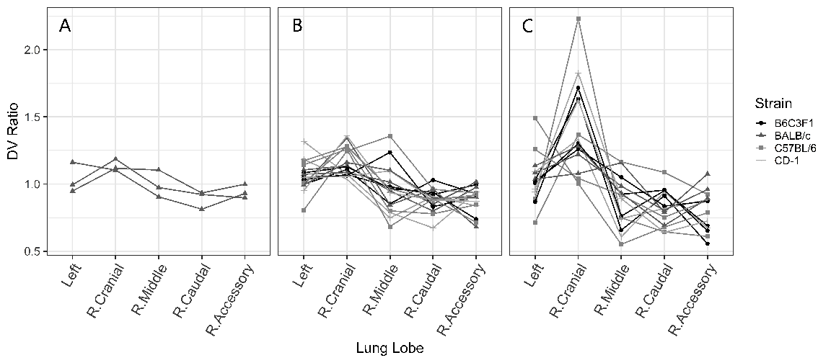
Figure 1. Individual DV ratio for each lobe of the mouse lung. A: 0.5 µm (N=3). B: 1 µm (N=16). C: 2 µm (N=14). R.: right.

Data showed in Figure 1 and Table 2 compare well with previous studies in rodents. Brain and colleagues (Brain, Knudson, Sorokin, & Davis, 1976) delivered aerosol (MMAD=1.6 µm) to both Syrian golden hamsters and Sprague Dawley rats in animal exposure chambers and determined the distribution of deposited particles through the evenness index (EI) defined as the ratio between normalized lobar deposition and normalized lobe weight (Figure 2A). In both species, the EI was larger than one in the cranial lobe (EI = 1.42 in hamsters and EI = 1.51 in rats) while EI in the left lobe was close to one (EI = 0.98 in hamsters and EI=1 in rats). In rats, they also observed an EI < 1 in the right middle, right accessory and right caudal lobes. Morgan et al. (Morgan et al., 1983) exposed SAS/4 mice to ²³⁹PuO₂ particles with a median aerodynamic diameter of 0.8, 1.5 and 2.2 µm. They observed EI larger than 1 in the cranial lobe and EI < 1 in the caudal and accessory lobe, with deviations from one increasing with increasing particle sizes, in agreement with data from this study (Table 2). Finally, in a more recent study, Yang and colleagues (Yang et al., 2019) delivered a liquid aerosol with a volume median diameter of 3.5 µm by mechanical ventilation to C57J/6 mice. Even though the particle size was larger than those used in this study, the DV ratio in each lobe show similar behavior as those observed in the C57J/6 mice included in this study (Figure 2B).
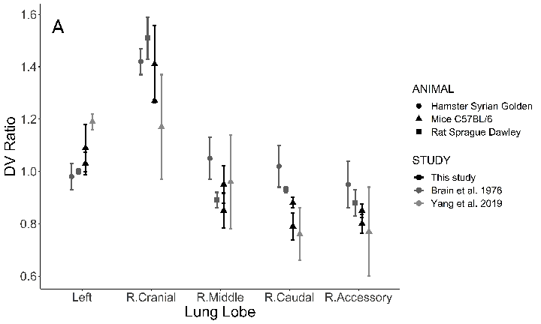
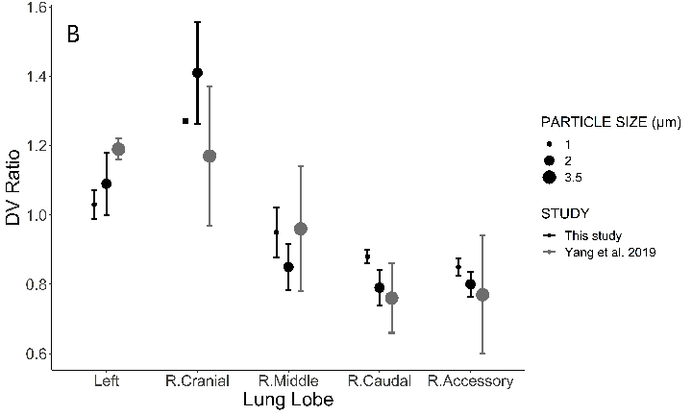
Figure 2. DV ratio in each lobe of the lung. A: comparison with previous studies in rodents (Hamster, mice and rats). B: effect of particle (mice only). R.: right.

The distribution of deposited particles in the lung is closely linked to the distribution of inhaled air among the different regions of the lungs (Bennett et al., 2002; Moller, Meyer, Scheuch, Kreyling, & Bennett, 2009). In humans (Milic-Emili, Henderson, Dolovich, Trop, & Kaneko, 1966) and large animals such as horses (Amis, Pascoe, & Hornof, 1984), the dependent lung region gets proportionally a larger fraction of a tidal breath than the nondependent lung regions. In contrast, in small animals such as the rat, the non-dependent lung region has been reported to be better ventilated than the dependent lung region (Rooney, Friese, Fraser, Dunster, & Schibler, 2009). This may explain the higher relative deposition in the non-dependent (cranial) than in the dependent lobes of the right lung (accessory and caudal) of rodents.

3.1 Near-acini deposition:
The shape of the distribution of near-acini deposition was also affected by particle size. Mice exposed to small aerosol particles (0.5 µm) tended to have a narrow, i.e. homogeneous, distribution (Figure 3A). On the contrary, for mice exposed to larger aerosol particles (1 and 2 µm), the distribution of near-acini deposition tended to be wider, indicating an increase in heterogeneity of near-acini deposition with increasing particle size (Figures 3B and C).

Figure 3. Histograms of near-acini deposition in BALB/c mice. A: 0.5 µm. B: 1 µm. C: 2 µm.

The distributions of near-acini deposition were characterized by their standard deviation (SD) and skew (Sk). Individual data for all 33 mice samples are plotted in Figure 4 against particle size. Median, quartiles (box) and 95% intervals (vertical line) are also displayed in the figures. Both standard deviation and skew significantly increased with increasing particle size. The rather small standard deviation of near-acini deposition for 0.5 µm particles indicates a homogeneous deposition throughout the lung for these small particles. These results also suggest that the homogenous deposition observed at the lobar level still occur at the near-acini level for this small particle size.
Figure 4. Parameters characterizing the near-acini deposition. Individual data are shown (closed symbols) along with the median and quartiles (box) and 95% confidence interval (vertical line). Significant p values are also shown. A: Standard deviation. B: Skew.

For all mice and particle size, skew was positive, i.e. the distribution was right-skewed. It has been previously shown that skew is a measure of hot spots of deposited particles. The larger the skew is, the more “hot spots” there are, i.e. the more there are near-acini units with higher particle deposition (hot spots) than expected from a normal distribution (Darquenne et al., 2013). Previous studies in humans showed that skew was inversely correlated with alveolar deposition (Garrard, Gerrity, Schreiner, & Yeates, 1981), implying that high values of skew are indicative of hot spots of deposited particles occurring predominantly in the bronchial airways. To our knowledge, there are no reports of skew of deposition distribution in rodents. Figure 5 displays the location of the top 1% of near-acini deposition relative to the airway tree structure for mice exposed to 0.5 (left), 1 (middle) and 2 µm particles (right panel). The data shown in Figure 5 are from the same BALB/c mice as those used in Figure 3 but similar distributions of hot spots were found in all of the 33 samples. Interestingly, the hot spots, while located relatively centrally, were only present in the apical region of the lungs, i.e. in the right cranial lobe and in the upper portion of the left lobe. These observations may explain the higher deposition measured in the right cranial lobe (Figure 1). As discussed above, the non-dependent region of the rodent lung is better ventilated than the dependent region. Because there is no major difference in the diameter of the airway of a given generation between lobes (data not shown), higher ventilation in the apical region of the lung results in higher velocities in the airways from the apical region than in similar airways located at the base of the lung. These high velocities increase the probability of a particle depositing by inertial impaction at airway bifurcation and thus increase the potential for the generation of hot spots. Indeed, of the three main mechanisms of aerosol deposition in the lung (inertial impaction, gravitational sedimentation and Brownian diffusion), inertial impaction is the only velocity-dependent mechanism (Darquenne, 2012).
Figure 5. Spatial location of the top 1% near-acini deposition (hot spots) in the same BALB/c mice as in Figure 3. Hot spots were mainly located toward the apex of the lung. A: 0.5 µm. B: 1 µm. C: 2 µm. See text for details.

Add graphs with top to bottom concentration gradient + discussion.

4. CONCLUSION (needs work once results finalized)
Analysis was performed on the newly available lapdMouse database to determine the special heterogeneity of aerosol deposition at lobar scale and near-acini scale. There was an uneven distribution of deposited particles among the lobes of the mouse lung. Particularly, the cranial lobe receives higher deposition comparing to its volume, and caudal and accessory lobes receive lower deposition. The unevenness increased with increasing particle size (0.5 – 2 µm). Thus, depending on the lobe, individual lobe analysis to determine overall deposition may either underestimate or overestimate total lung burden, at least for particles in the micron size range. At near acini level, larger particle size was associated with higher likeness of formation of hot spots and a less uniform spatial distribution of particle deposition.

ACKNOWLEDGEMENTS
The study was partially funded by U01ES028669 from NIEHS at NIH.

REFERENCES
Amis, T. C., Pascoe, J. R., & Hornof, W. (1984). Topographic distribution of pulmonary ventilation and perfusion in the horse. Am J Vet Res, 45, 1597-1601.
Asgharian, B., Miller, F. J., Price, O., Schroeter, J. D., Einstein, D. R., Corley, R. A., & Bentley, T. (2016). Modeling particle deposition in the pig respiratory tract. Journal of Aerosol Science, 99, 107-124.
Bauer, C., Krueger, M. A., Lamm, W. J., Glenny, R. W., & Beichel, R. R. (2020). lapdMouse: associating lung anatomy with local particle deposition in mice. Journal of Applied Physiology, 128, 309-323.
Beichel, R. R., Glenny, R. W., Bauer, C., Krueger, M. A., & Lamm, W. J. (2019). Lung anatomy + particle deposition (lapd) mouse archive. University of Iowa.
Bennett, W. D., Brown, J. S., Zeman, K. L., Hu, S. C., Scheuch, G., & Sommerer, K. (2002). Targeting delivery of aerosols to different lung regions. J Aerosol Med, 15, 179-188.
Brain, J. D., Knudson, D. E., Sorokin, S. P., & Davis, M. A. (1976). Pulmonary distribution of particles given by intratracheal instillation or by aerosol inhalation. Environmental Research, 11, 13-33.
Darquenne, C. (2012). Aerosol deposition in health and disease. J Aerosol Med Pulm Drug Deliv, 25, 140-147. doi: DOI: 10.1089/jamp.2011.0916
Darquenne, C., Zeman, K. L., Sa, R. C., Cooper, T. K., Fine, J. M., Bennett, W. D., & Prisk, G. K. (2013). Removal of sedimentation decreases relative deposition of coarse particles in the lung periphery. Journal of Applied Physiology, 115, 546-555. doi: doi:10.1152/japplphysiol.01520.2012
De Backer, J. W., Vos, W. G., Gorle, C. D., GermonprÇ, P., Partoens, B., Wuyts, F. L., . . . De Backer, W. (2008). Flow analyses in the lower airways: Patient-specific model and boundary conditions. Med.Eng.Phys., 30, 872-879.
Garrard, C. S., Gerrity, T. R., Schreiner, J. F., & Yeates, D. B. (1981). The characterization of radioaerosol deposition in the healthy lung by histogram distribution analysis. Chest, 80(suppl), 840-842.
Hofmann, W. (2011). Modeling inhaled particle deposition in the human lung: A review. Journal of Aerosol Science, 42, 693-724.
Kabilan, S., Suffield, S. R., Recknagle, K. P., Jacob, R. E., Einstein, D. R., Kuprat, A. P., . . . Corley, R. A. (2016). Computational fluid dynamics modeling of Bacillus anthracis spore deposition in rabbit and human respiratory airways. Journal of Aerosol Science, 99, 64-77.
Ma, B., & Lutchen, K. R. (2009). CFD simulation of aerosol deposition in an anatomically based human large-medium airway model. Annals of Biomedical Engineering, 37, 271-285.
Milic-Emili, J., Henderson, J. A. M., Dolovich, M. B., Trop, D., & Kaneko, K. (1966). Regional distribution of inspired gas in the lung. Journal of Applied Physiology, 21, 749-759.
Moller, W., Meyer, G., Scheuch, G., Kreyling, W. G., & Bennett, W. D. (2009). Left-to-right asymmetry of aerosol deposition after shallow bolus inhalation depends on lung ventilation. J Aerosol Med Pulm Drug Deliv, 22, 333-339.
Morgan, A., Black, A., Moores, S. R., Pritchard, J. N., Walsh, M., & Lambert, B. E. (1983). Alveolar Deposition of Sized Particles of 239 PuO2 in the Mouse. Radiation Research, 93, 85-92.
Rooney, D., Friese, M., Fraser, J. F., Dunster, K. R., & Schibler, A. (2009). Gravity-dependent ventilation distribution in rats measured with electrical impedance tomography. Physiological Measurement, 30, 1075-1085.
Vinchurkar, S., De Backer, L., Vos, W., Van Holsbeke, C., De Backer, J., & De Backer, W. (2012). A case series on lung deposition analysis of inhaled medication using functional imaging based computational fluid dynamics in asthmatic patients: Effect of upper airway morphology and comparison with in-vivo data. Inhalation Toxicology, 24, 81-88.
Yang, L., Feuchtinger, A., Moller, W., DIng, Y., Kutschke, D., Moller, G., . . . Schmid, O. (2019). Three-Dimensional Quantitative Co-Mapping of Pulmonary Morphology and Nanoparticle Distribution with Cellular Resolution in Nondissected Murine Lungs. ACS Nano, 13, 1029-1041.

FIGURE LEGENDS
Figure 1: Individual DV ratio for each lobe of the mouse lung. A: 0.5 µm (N=3). B: 1 µm (N=16). C: 2 µm (N=14). R.: right.

Figure 2: DV ratio in each lobe of the lung. A: comparison with previous studies in rodents (Hamster, mice and rats). B: effect of particle (mice only). R.: right.

Figure 3: Histograms of near-acini deposition in BALB/c mice. A: 0.5 µm. B: 1 µm. C: 2 µm.

Figure 4: Parameters characterizing the near-acini deposition. Individual data are shown (closed symbols) along with the median and quartiles (box) and 95% confidence interval (vertical line). Significant p values are also shown. A: Standard deviation. B: Skew.

Figure 5: Spatial location of the top 1% near-acini deposition (hot spots) in the same BALB/c mice as in Figure 3. Hot spots were mainly located toward the apex of the lung. A: 0.5 µm. B: 1 µm. C: 2 µm. See text for details.

